PM SHRI KENDRIYA VIDYALAYA
HOLIDAY HOME WORK (WINTER BREAK)
CLASS III

ENGLISH
- Revise syllabus of PT 2 (from the chapter- Puppy and I to Don’t tell)
- Read any 5 moral stories and prepare any one for the narration in the class.
- Using the suffix: -ly , -ful , -ed , -ish , make 5 new words for each.
- Read English Newspaper daily and learn new words too.
EVS
- Write 10 -10 objects that sink and float .While Doing experiment click pictures and paste it on A4 sheet .
- Do Complete your pending work.
- Learn chapters from Sharing Our Feelings to Our Friends – Animals for PT-2 exams

हिंदी
1. प्रतिदिन हिंदी समाचार पत्र की मुख्य दो खबरों को पढ़ने का अभ्यास करें।
2. हिंदी की पुस्तक 'रिमझिम' की कविता 'मिर्च का मज़ा' को याद करें।
3. PT -2 परीक्षा के लिए पाठ 'कब आऊँ' से लेकर पाठ 'जब मुझको साँप ने काटा' तक के सभी पाठों के अभ्यास कार्य को दोहरा लें।
4. कोई एक नैतिक (शिक्षाप्रद ) कहानी लिखें और उससे संबंधित चित्र भी बनाएं। (A4 साइज लाइन वाली शीट पर)।
5. दिए गए अपठित गद्यांशों को पढ़ें और पूछे गए प्रश्नों के उत्तर दें-
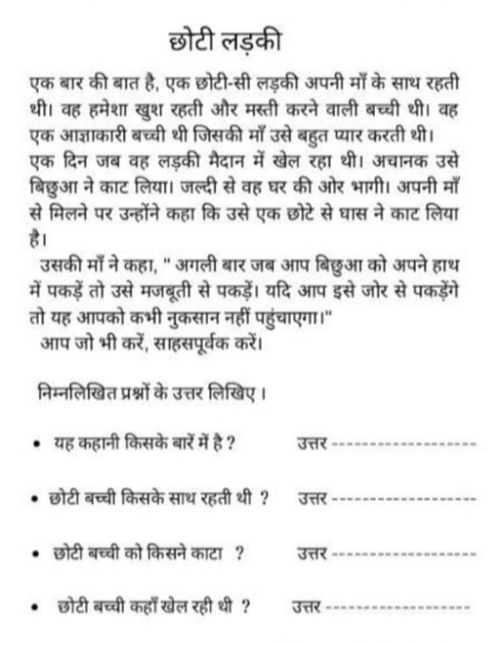
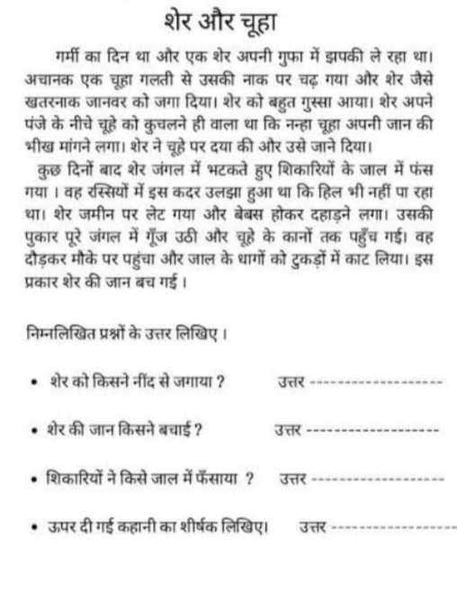
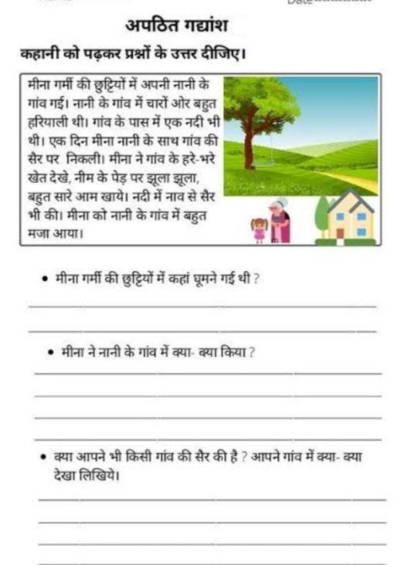

MATHS
1. Make a Multiplication Tree on A4sheet. ( reference page no- 131 of your maths magic NCERT textbook)
2. Make your own patterns (only 2) using numbers and alphabets on A4 sheet.
5. Learn tables upto 20.
6. Prepare for PT 2, scheduled in January (Play with patterns, Who is Heavier and How many times)

MDP FILE WORK
MATHS
- Draw and write the name of the container that holds liquid.
  - More than 1 litre
  - Less than 1 litre
- Take a 1 litre empty transparent water bottle mark 250ml, 500ml, 750ml on it using permanent marker.(Take help of your parents)

ENGLISH
- How can we Reduce Water Waste at home.
- How is rain useful to us? Explain with an example.
- Write 10 -10 objects that sink and float. While Doing experiment click pictures and paste it on A4 sheet .
EVS
1. Draw rain water harvesting & write few lines on it.
2. Write 5 ways to save water and paste pictures also. (A4 size sheet)

